**JAVASCRIPT – Events**

1. **What is an Event?**

An HTML event can be something the browser does, or something a user does.

Here are some examples of HTML events:

* An HTML web page has finished loading
* An HTML input field was changed
* An HTML button was clicked

1. **onclick Event Type**

The onclick event occurs when the user clicks on an element.

**​​<button onclick="this.innerHTML = Date()">The time is?</button>**

1. **onsubmit Event Type**

The onsubmit event occurs when a form is submitted.

**<form onsubmit="myFunction()">**

**Enter name: <input type="text">**

**<input type="submit">**

**</form>**

1. **onmouseover and onmouseout**

**Onmouseover** Execute a JavaScript when moving the mouse pointer onto an image:

**<img onmouseover="bigImg(this)" src="smiley.gif" alt="Smiley">**

**Onmouseout** Execute a JavaScript when moving the mouse pointer out of an image:

**<img onmouseout="normalImg(this)" src="smiley.gif" alt="Smiley">**

1. **HTML 5 Standard Events**

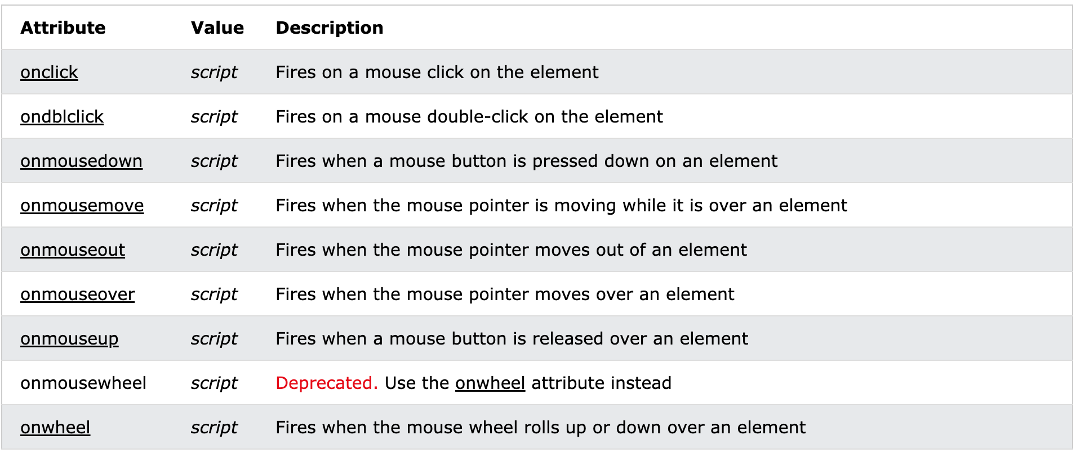

**JAVASCRIPT – Cookies**

1. **What are Cookies?**

A cookie is an amount of information that persists between a server-side and a client-side. A web browser stores this information at the time of browsing.

1. **How Does It Work?**

* When a user sends a request to the server, then each of that request is treated as a new request sent by the different user.
* So, to recognize the old user, we need to add the cookie with the response from the server.
* browser at the client-side.
* Now, whenever a user sends a request to the server, the cookie is added with that request automatically. Due to the cookie, the server recognizes the users.

1. **Storing Cookies**

JavaScript can create, read, and delete cookies with the document.cookie property. With JavaScript, a cookie can be created like this:

**document.cookie = "username=John Doe";**

1. **Reading Cookies**

With JavaScript, cookies can be read like this:

**let x = document.cookie;**

**document.cookie will return all cookies in one string much like: cookie1=value; cookie2=value; cookie3=value;**

1. **Setting Cookies Expiry Date**

**​​var a = new Date();**

**a = new Date(a.getTime() +1000*60*60*24*365);**

**document.cookie = 'mycookie=somevalue; expires='+a.toGMTString()+';';**

1. **Deleting a Cookie**

Deleting a cookie is very simple.

You don't have to specify a cookie value when you delete a cookie.

Just set the expires parameter to a past date:

document.cookie = "username=; expires=Thu, 01 Jan 1970 00:00:00 UTC; path=/;";

**JAVASCRIPT – Page Redirect**

1. **What is Page Redirection?**

Redirect is nothing but a mechanism of sending search engines and users on a different URL from the original one. The redirected page can be on the same server or on a different server. It can also be on the same website or on different websites.

1. **JavaScript Page Refresh**

Reload the current document:

**location.reload();**

1. **Auto Refresh**

If you want refresh the page you could use like this

<script language="javascript">

setTimeout(function(){

window.location.reload(1); }, 30000);

</script>

1. **How Page Redirection Works?**

It is quite simple to do a page redirect using JavaScript at client side. To redirect your site visitors to a new page, you just need to add a line in your head section as follows.

**<script type = "text/javascript">**

**function Redirect() {**

**window.location="https://www.tutorialspoint.com";**

**}**

**</script>**

**JAVASCRIPT – Dialog Box**

1. **Alert Dialog Box**

An alert box is often used if you want to make sure information comes through to the user.

When an alert box pops up, the user will have to click "OK" to proceed.

**alert("I am an alert box!");**

1. **Confirmation Dialog Box**

A confirm box is often used if you want the user to verify or accept something.

When a confirm box pops up, the user will have to click either "OK" or "Cancel" to proceed.

If the user clicks "OK", the box returns true. If the user clicks "Cancel", the box returns false.

**if (confirm("Press a button!")) {**

**txt = "You pressed OK!";**

**} else {**

**txt = "You pressed Cancel!";**

**}**

1. **Prompt Dialog Box**

A prompt box is often used if you want the user to input a value before entering a page.

When a prompt box pops up, the user will have to click either "OK" or "Cancel" to proceed after entering an input value.

If the user clicks "OK" the box returns the input value. If the user clicks "Cancel" the box returns null.

**let person = prompt("Please enter your name", "Harry Potter");**

**let text;**

**if (person == null || person == "") {**

**text = "User canceled the prompt.";**

**} else {**

**text = "Hello " + person + "! How are you today?";**

**}**

**JAVASCRIPT – Void Keyword**

The word void means "completely empty space" according to the dictionary. This term, when used in programming, refers to a return of "nothing" - an "empty value" so to speak.

**JAVASCRIPT – Page Printing**

1. **How to Print a Page?**

The print() method prints the contents of the current window.

**window.print();**